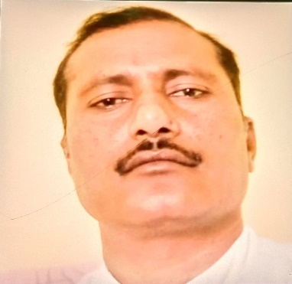

**Dr. Mukesh Kumar**

Principal

Education Department, Nimbus School of Education, Dehradun (U.K)

**Contact:**

Email-mukeshkumar2276@gmail.com

Phone: +91-9528186584

**Education:**

Ph.D. in Education (2011) from C.C.S University Meerut.

M.Ed. in 2005 from Rajasthan University Jaipur Raj.

M.A in Sanskrit (2014) from C.C.S University Meerut.

B.Ed. in 2003 from C.C.S University Meerut.

B.A.in 2000 from C.C.S University Meerut.

**Teaching**:

Teaching of Sanskrit

**Academic Experience**:

15 years’ teaching experience in B.Ed. college

**Professional Experience:**

Nimbus School of Education

Nimbus Academy of management